1. 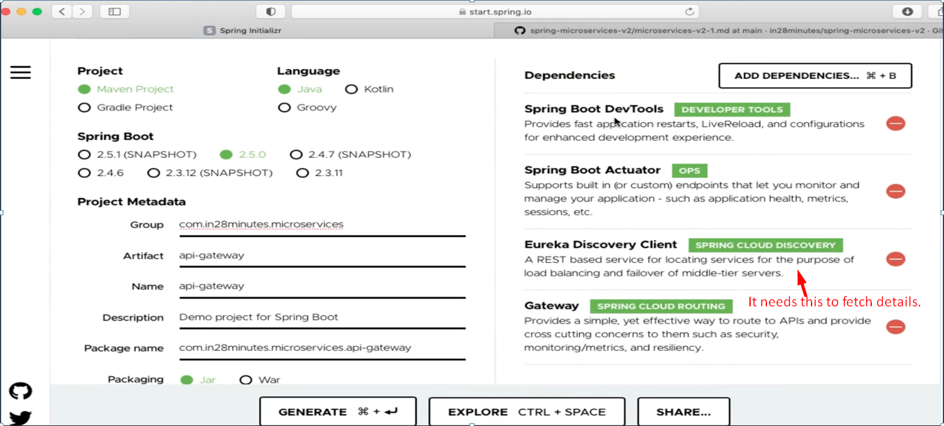
2. 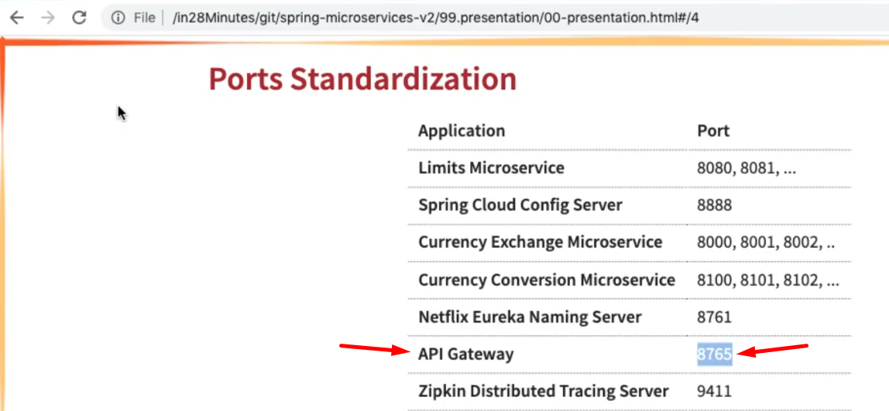
3. 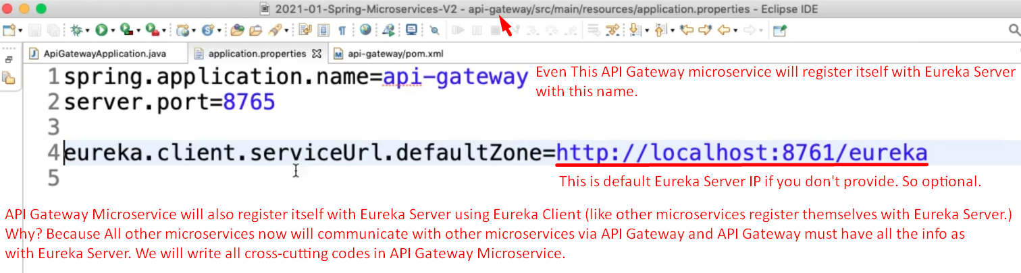
4. 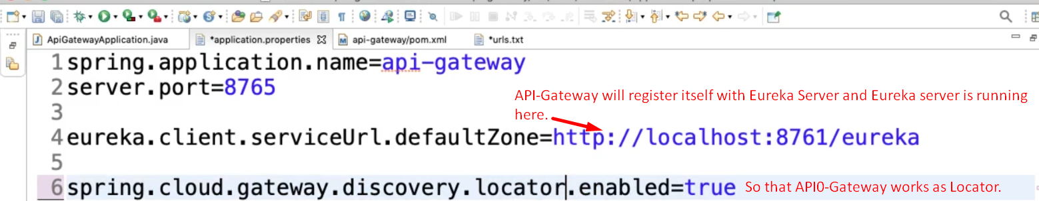  
   **NOTE**: The following property is also working. See the hyphen in service-url whereas in the above snapshot it is just “serviceUrl” without hyphen.  
   eureka.client.service-url.defaultZone=http://localhost:8761/eureka
5. This configuration is enough to register api-gateway microservice with Eureka Server.